**Data Analyst in Power BI Data-Camp 2025**

**Section 10: DAX Functions in Power BI**

1. **Setting up Data Models with DAX**

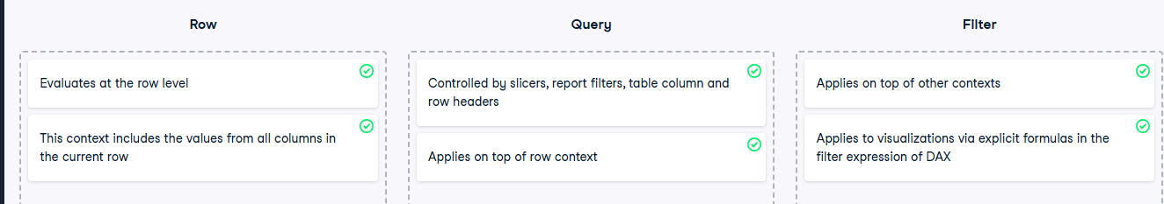

**Exercise 1.1** 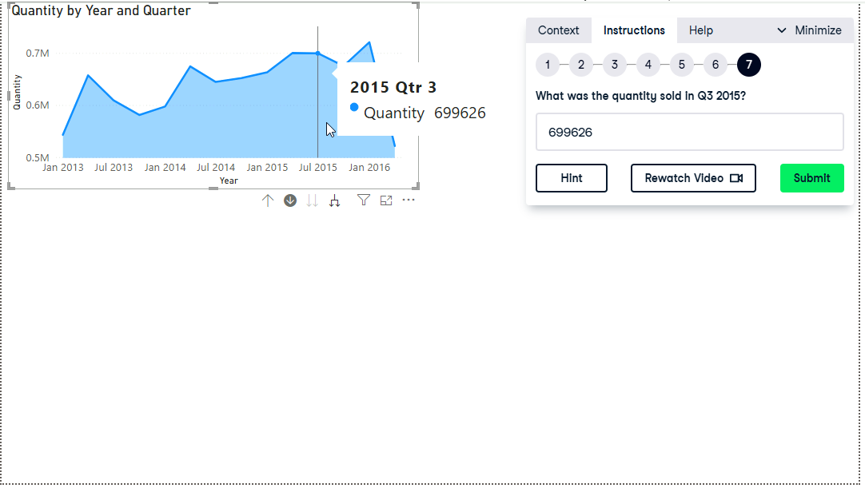

**Exercise 1.2**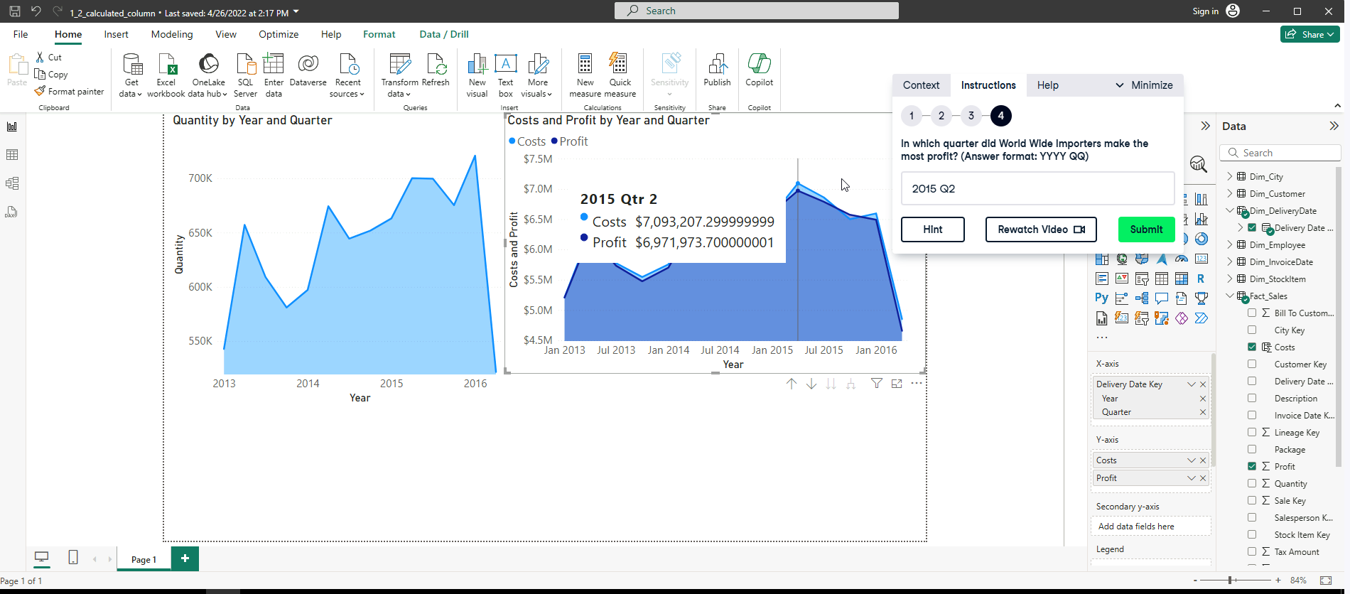

**Exercise 1.3**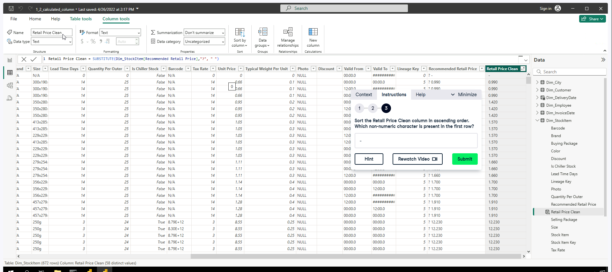

**Exercise 1.4**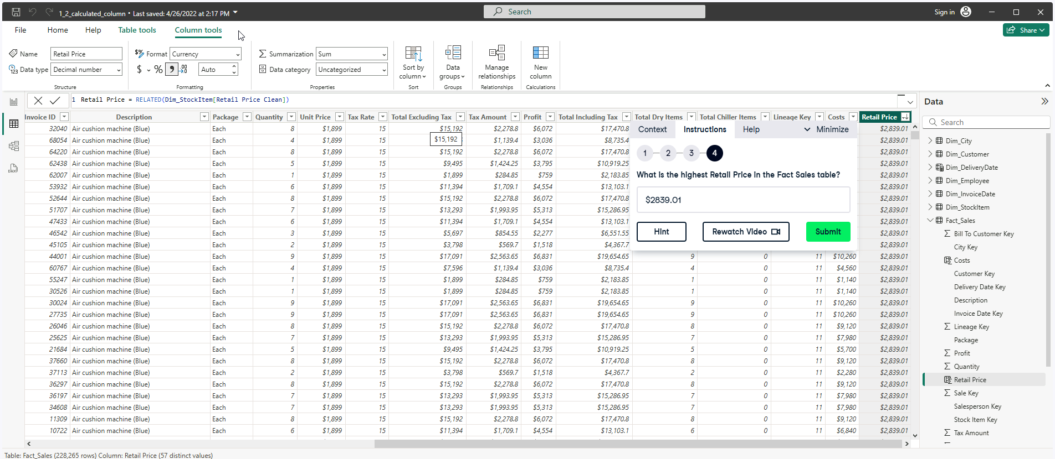

**DAX and Measures**

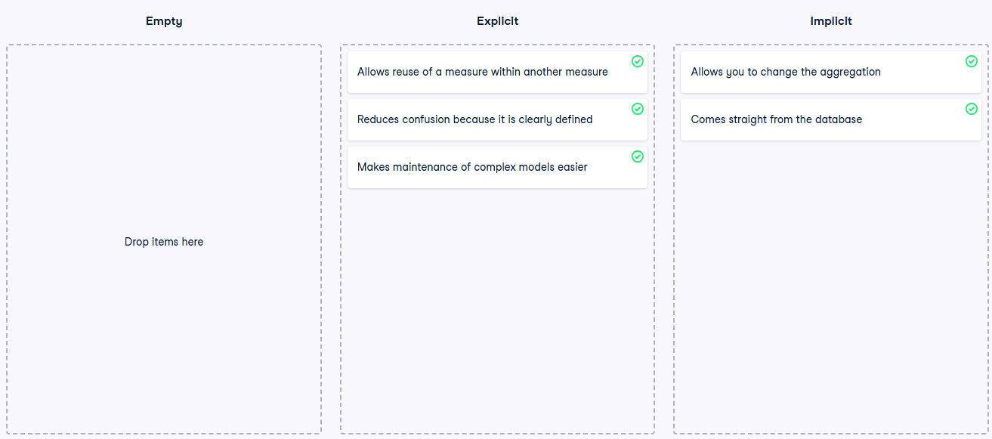

Dax Measure for Sales YOY% New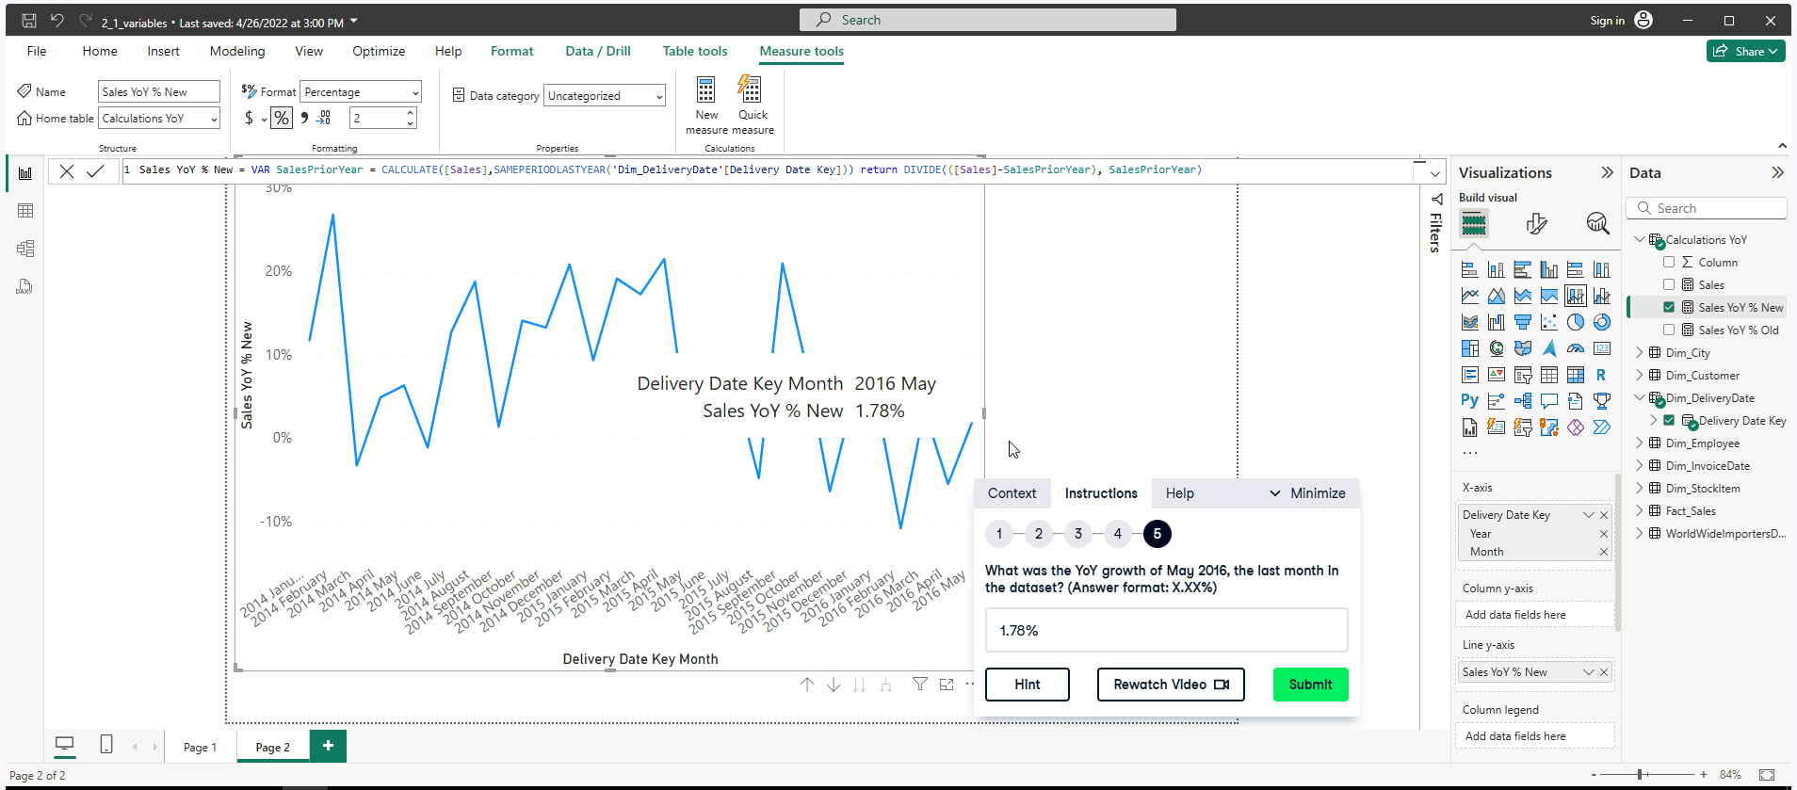

**Exercise 2.2**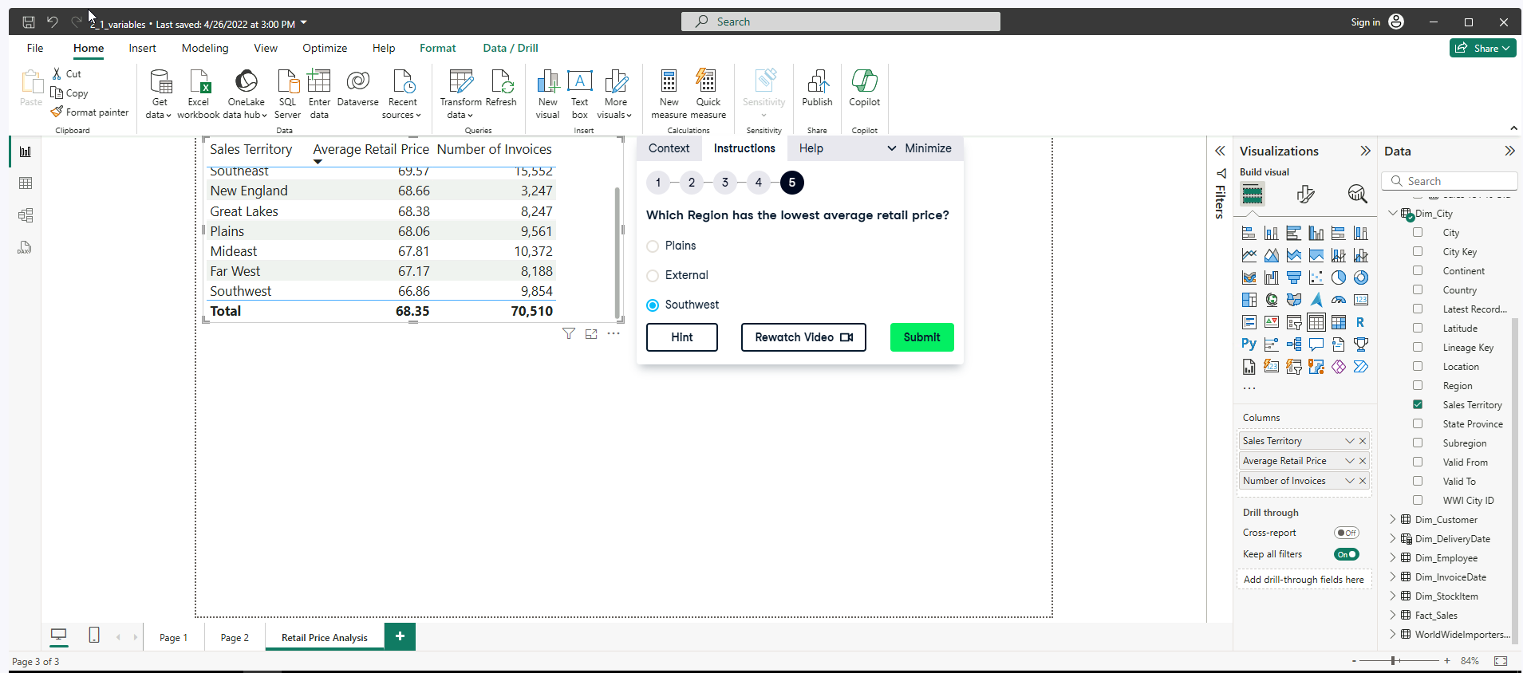

**Exercise 2.3**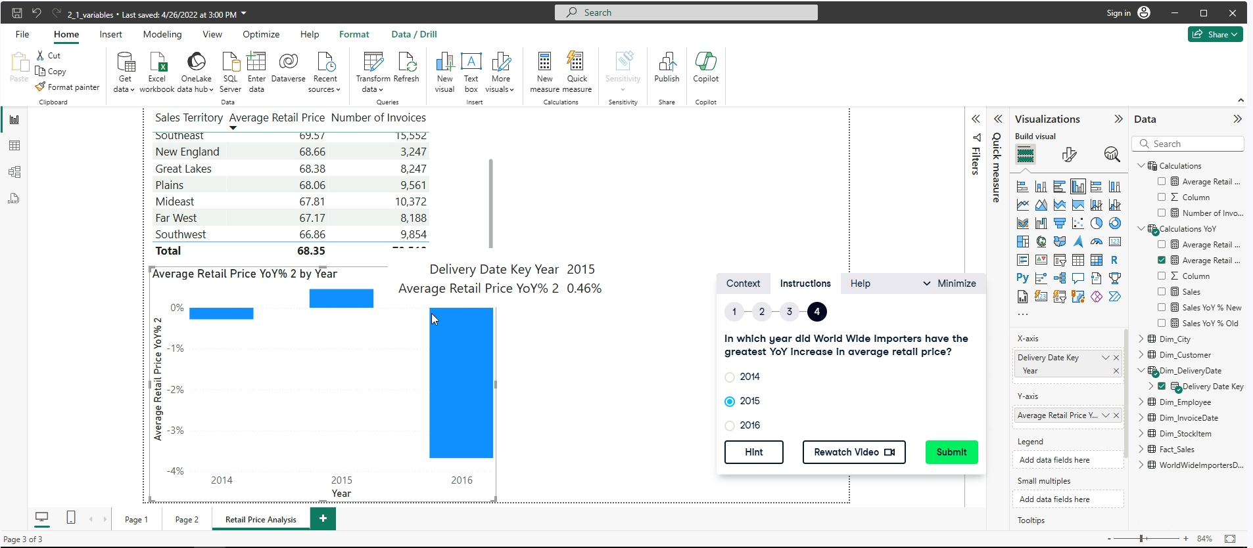

**Filtering and Counting with DAX**

**Exercise 3.1**

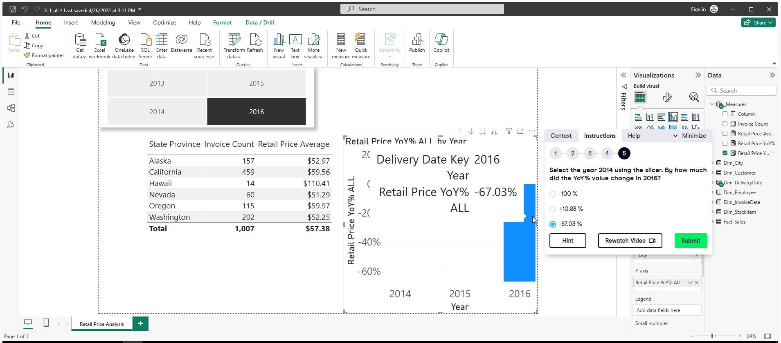

DAX MEASURE to give Retail Price YOY% through all calendar years.

* Retail Price YoY% ALL = CALCULATE([Retail Price YoY%],ALL(Dim_InvoiceDate[Calendar Year]))

**Exercise 3.2**

DAX MEASURE Total Sales Chiller calculates Total Sales from the fact table, includes chilled items by using FILTER()

* Total Sales Chiller = CALCULATE([Total Sales], FILTER(Fact_Sales, RELATED(Dim_StockItem[Is Chiller Stock]) = TRUE)) **A screenshot of a computer

  AI-generated content may be incorrect.**

**Iterating Functions**

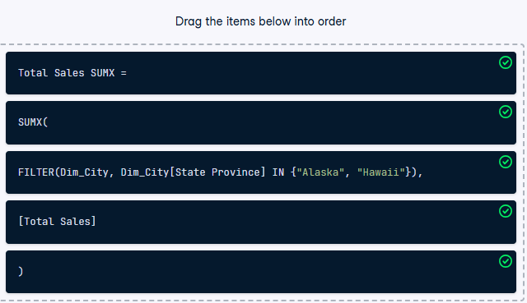**Exercise 4.1**

CREATING A DAX MEASURE FOR PROFIT RATIO,

* Profit Ratio = AVERAGEX(Fact_Sales, DIVIDE(Fact_Sales[Profit],[Total Sales]))
* Profit Ratio = AVERAGEX(Fact_Sales, Fact_Sales[Profit]/[Total Sales]) 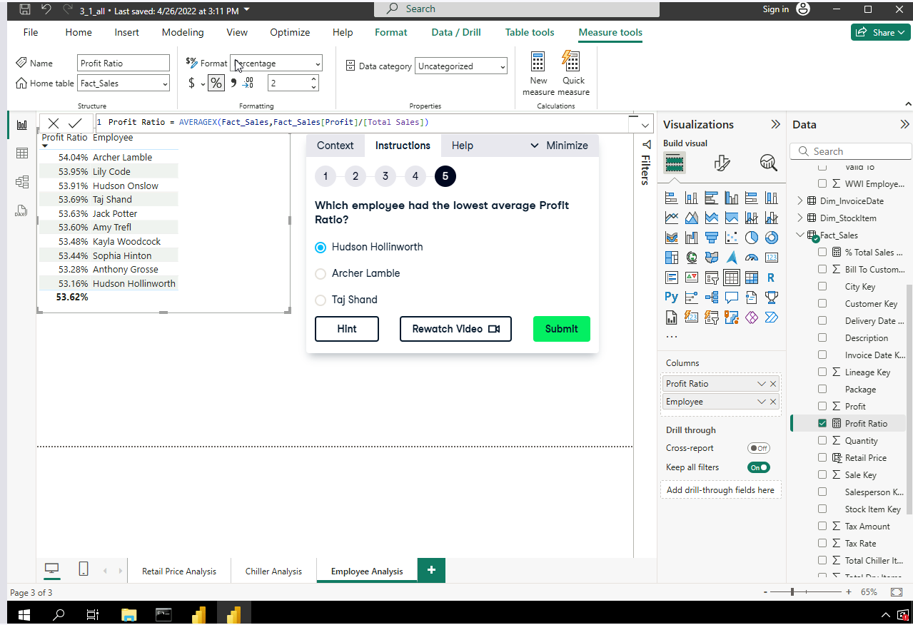

**Exercise 4.2**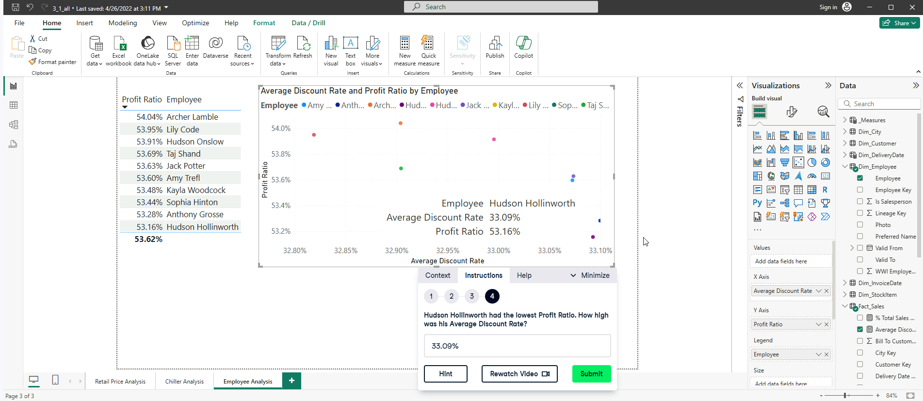

CREATING A DAX MEASURE FOR AVERAGE DISCOUNT RATE,

* Average Discount Rate = AVERAGEX(Fact_Sales, DIVIDE(Fact_Sales[Retail Price]-Fact_Sales[Unit Price],Fact_Sales[Retail Price]))
* Average Discount Rate = AVERAGEX(Fact_Sales, (Fact_Sales[Retail Price]-Fact_Sales[Unit Price])/Fact_Sales[Retail Price])

**Exercise 4.3**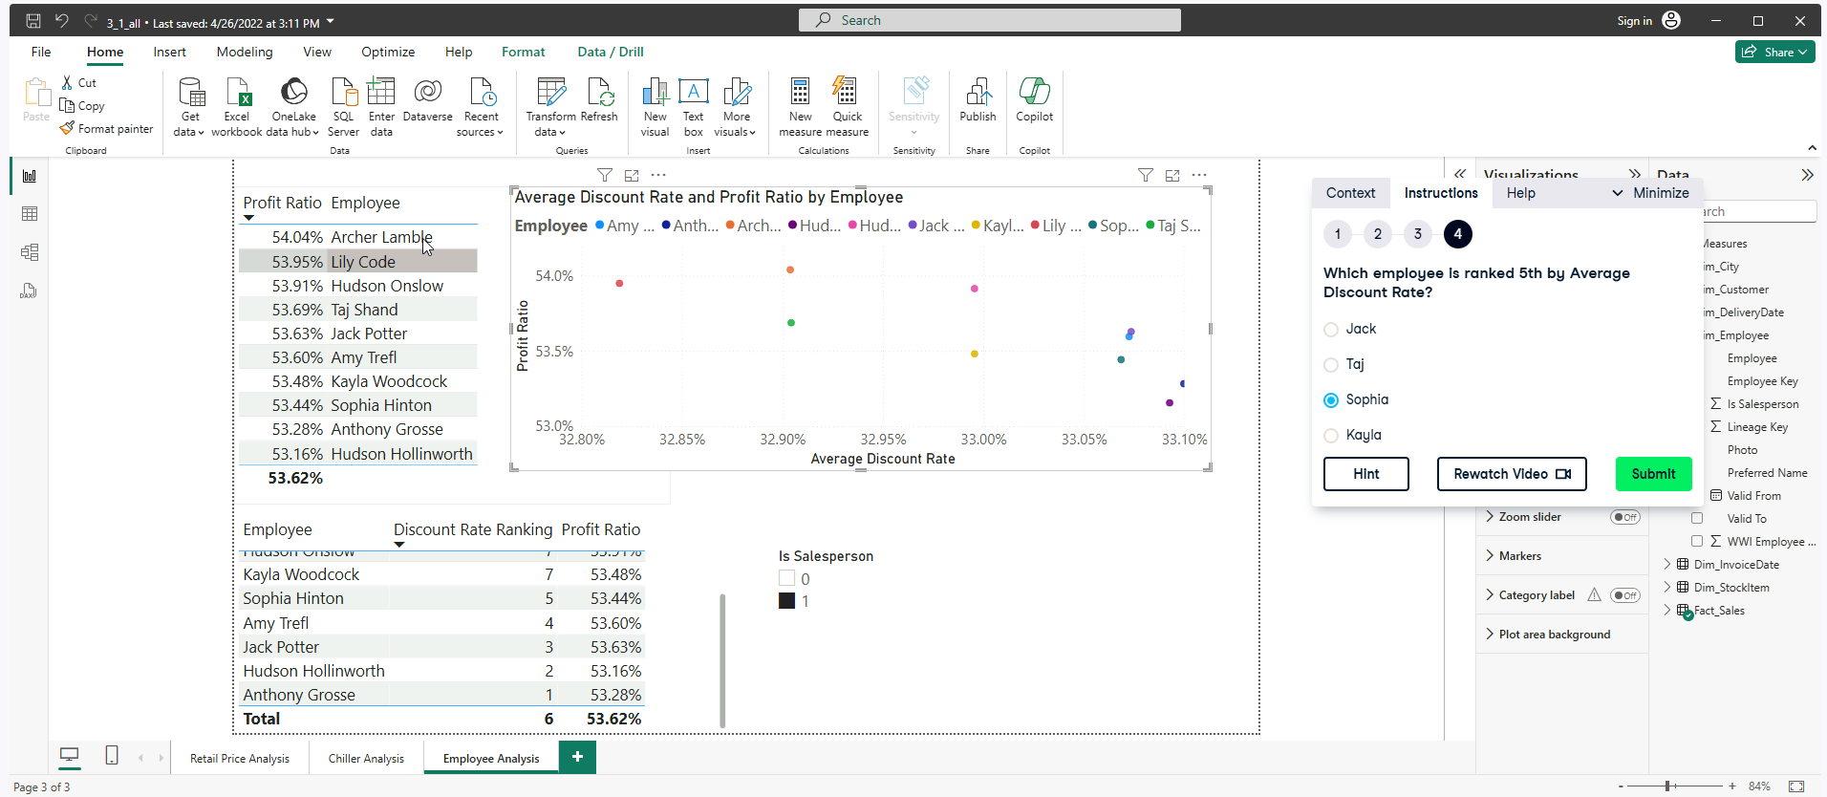

* Discount Rate Ranking = RANKX(ALL(Dim_Employee[Employee]),[Average Discount Rate])